The Class of 1986 News Journal
News and Announcements from the Lobo Class of ’86 Family (Via Facebook)
May 2014
Dana Lilly-Dessesaure Graduates from LeTourneau University
Saturday, May 3
Congratulations to Dana Lilly Dessesaure on graduating from LeTourneau University! She received her Bachelor of Human Services May 3rd.

SHOUT-OUT CORNER!
Every month we will send shout-outs to various classmates-

(Shout-out- another way of saying, “Hi”, “What’s up?”, or “How are you doing?”)

SHOUT-OUTS TO:
John English
Jamie Ivy-Launius and Family
Jackie Garrett-Murphy
Shelia Parr-Sexton
Chris Cotton
Evelyn Johnson-Hines
Tim Tutt
John Hackler
Melanie Braun-McDaniel
Deborah Pryor-Fuller
Kenneth Brantley
Rodney Jackson
Lisa Skinner
Tamala Jackson
Yolanda Starling-Crowe
Angie Clark-White
Kara Taylor-Baker
Terri Anderson-Simpson
Connie George
Wytaine Smith



.
86QUOTES:
(Lifted From Facebook)
Heavenly Father, first we want to give glory and honor to you! And ask you for your divine favor as myself and my fellow classmates began to take our finals the next two days . We make you big in our lives God, to allow your Holy Spirit to bring those thing back to our remembrance as we go in in Jesus name, amen!!!!! Let's lift him up!!!- Tunga Tatum-Hicks

"Success consists of going from failure to failure without loss of enthusiasm." - Winston Churchill
From Robert Darden

Psalm 33:4
For the word of the LORD is right and true; he is faithful in all he does. From Keith Castillo

Some of us brag about what we have, what we've accomplished. It's amazing how we can have so much fortune and do all of these great things by ourselves and never mention God while we're bragging. Please let me in on how you accomplish all of these great things without him
Ms. Superwoman and Mr. Superman.
From Clyde Boyd

Kevin Durant you are class and a true MVP. I was very moved by your speech and how you thanked each of your team members and especially the story of what your mother sacrificed for you and your brother. I saw him in tears for his opportunity to play the game he loves. All the other superstars could learn from him how to let your actions speak for you. True MVP- From Tim King

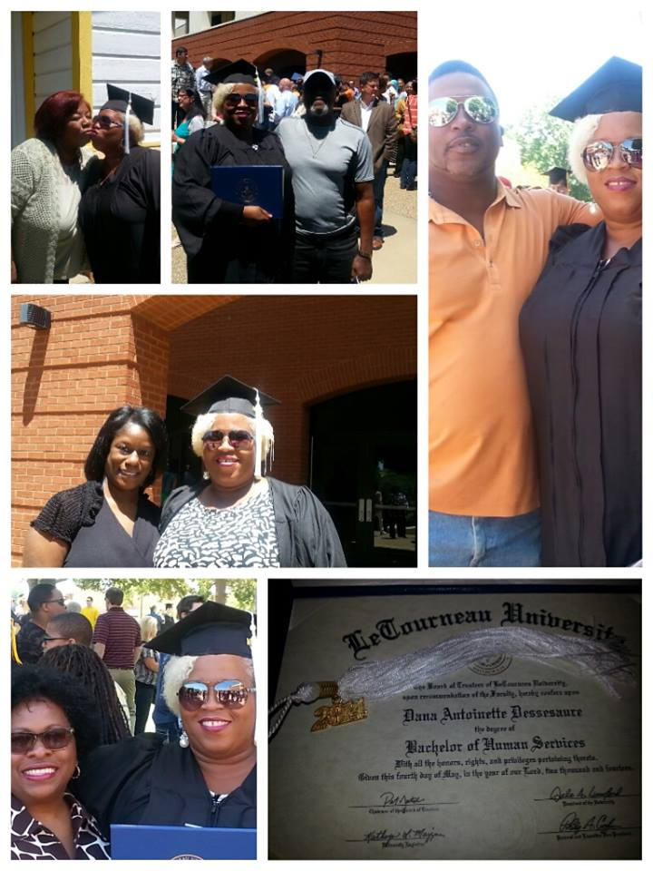

Inside This Issue
1 | Shout-Out Corner
2 | Bits and Pieces From The Class of ‘86
3 | 86Quotes
3 | Calendar of Events
4 | Class of 86 Recipe Book


Bits and Pieces from The Class of ‘86

William Muckleroy is enjoying his family-

Kirt Villyard is still enjoying life as usual!


Robert Darden continues to be a great Papi!


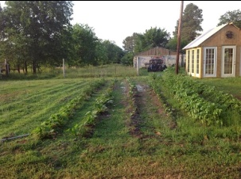

Blakely Bates can grow some grass (not the illegal kind, mind you-)



Goat....its what's for dinner- Chris Miller


Sitting on the dock of the bay- Rodney Jackson

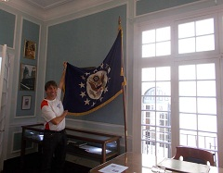

Joe Ireland continues to travel the world…

Thanks to the following classmates for leaving comments or liking my link to the Lobo Class of 1986 Page: Niki Starr, Choyce Gray-Thomas, Frances Meador, Stacy Windsor-Bragg, Kirt Villyard, Chris Cotton, Teresa Farris-Acosta, Amy McCullin-Rheams, Kerrie Cobb-Mathews, Sarah Herring-Claburn, Mona Leach, Roy Craine, Lisa Skinner, William Muckleroy, Teresa Farris-Acosta, Kara Taylor-Baker, Kim Pritchard, Jackie Garrett-Murphy, Marcus Williams, Melanie Braun-McDaniel, Keith Castillo, Danza Reavis-Martin, Ken Beishir, Kim Russell-Brown, Frank Coleman, Joe Ireland, Tammy Allen, Kim Williams-Gunn, Tim King, Sheryl Perry-Smith, LaTrenna Hughes-Coss, John Coss, John Hackler, Kevin Wyatt, Nancy Davis-Taylor, Sharissa Lea-Barrett, Micheal Grugel, Deborah Pryor-Fuller, Gloria Woods, Clyde Boyd, Jeff Hampton, Randy Polk, John Shiver, Alicia Ellis-Williams, Connie George, Lori Dahl-Waples, Todd Lucas, Angie Clark-White, Lisa Supercinski-Muller
(Hope I didn’t forget anyone!)

Calendar of Events
EVENT
Place
Time
(No upcoming events listed yet)

Check out these links:

Class of 86 Recipe Book
From Wytaine Smith
Kickin' Sloppy Joe & Cheddar Pie

http://www.hispanickitchen.com/profiles/blogs/kickin-sloppy-joe-cheddar-pie

The Lobo Class of 1986 Webpage
THE BEST CLASS EVER!

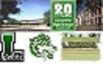

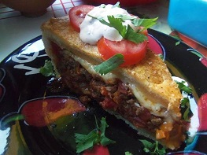

http://www.acedwardslobos86.com/LOBO86/Class86.html

Cedric E. Tales of the House Rocker Blog



http://cedric-e.blogspot.com/

If anyone has any news or announcements they would like to see in The Class of 86 News Journal, please send these to:

cedric@acedwardslobos86.com

*
And, if anyone can think of a better name to give our little newsletter, please send in any suggestions to the above address- (But if you like the name- The Class of 86 News Journal- let me know that, too!)
*

This newsletter has plenty of space! If anyone has anything they would like advertised, please also send these to the above address, and we’ll be sure to include it in the next newsletter!

Have a great and blessed month!

